**Title: Pothole Detection using smartphone’s accelerometer sensor**

**Tell us what your idea is.**

Abstract:

*Pot-holes on road will make transportation slower and costly. India has a big network of roads to connect the villages and cities, the authority persons cannot travel across the region for identification of holes.As per advancement in machine learning in recent time, we can use this technology for the identification of potholes and reporting to road ministry and also to other users so that they can find safe routes.We can use smartphone sensors (such as Accelerometer and Gyroscope) to identify the pot-holes on road and GPS for the location. The major task of this problem is to capture the data and annotation. I am developing a mobile application for capturing changes observed in accelerometer data. I can apply different machine learning algorithms to this raw-data. When a pothole is detected the application will plot the location of that pot hole on map. This information can be further given to Ministry of Road Transport and Highways.*

How will this app work?

*Inside a car a mobile phone will be placed on Mobile Holder. User will start the app. The app shows Google Maps in Foreground. In the background, Accelerometer and GPS data is constantly stored in SQLite storage. When a car passes by a Pothole a displacement is observed in Accelerometer data. We can use TensorFlow Lite to perform ML algorithm on this local data. This algorithm will identify potholes by monitoring accelerometer data and if pothole is detected then the GPS location is uploaded to Firebase real time database. This Firebase real time database’s data is plotted on foreground which can be viewed by every other user.*

*Accelerometer data for Normal anomalies*

*Accelerometer data 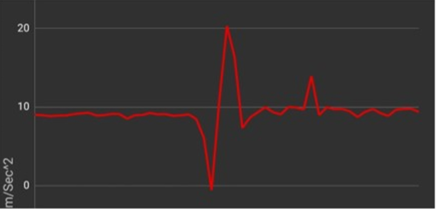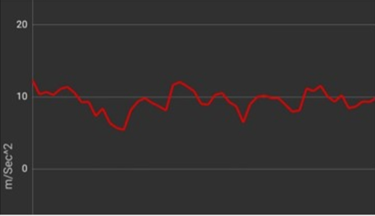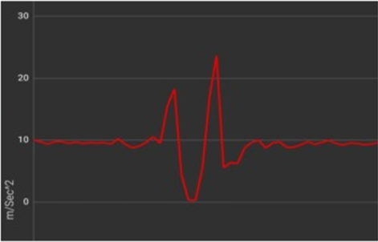for Pothole*

*Accelerometer data for speed breaker*

How we will capture all this data?

*Taxi drivers in India uses applications like UBER and OLA. If this functionality is given in those applications then we can collect a lot of data regarding where are potholes. The number of times the pothole is registered is the number of times a car is passed through that pothole. Which means that we can find where are major potholes.*

*This can be also implemented in Google Maps’s Directions to provide even faster and safe routes.*

*Developers talked about “Automatic Accident Detection” in Android Dev Summit 2019. That project is also based on Accelerometer data and Microphone so this functionality can be also added into that project.*

*Mission is not to find each and every pothole hole. Mission is to find potholes which are affecting large number of vehicles. So that those roads should be fixed first.*

**Tell us how you plan on bringing it to life.**

*Currently I have developed an app to store Accelerometer and GPS data into SQLite storage and I have also developed an app in which I have stored some random Latitude , Longitude locations in Firebase and marking them on maps using Google maps API.*

*I am doing some research regarding which Machine Learning algorithm should fit best for monitoring accelerometer data and which classification algorithm should I use.* *Accelerometer Data generated by each user will be huge so we should perform ML algorithm locally. I need guidance for performing ML tasks locally without need of dedicated online server.*

1. ***<https://github.com/shreyash0k/PotholeDetection>*** *is repository where you can find my progress*
2. *I need help and guidance for performing Machine Learning algorithms efficiently on Mobile Processor locally.*
3. *Timeline* 
   * *Dec 2020 work on ML kit and TensorFlowLite and find best fit algorithm*
   * *Jan 2020 Train model by driving through potholes*
   * *Jan 2020-Feb 2020 Test application in different vehicles*
   * *Mar 2020 Modifications based on testing results*
   * *April 2020 uploading on Google Play Store and Beta Testing.*

**Tell us about you.**

*My name is Shreyash Karandikar. I am from Mumbai, India.*

*I am studying Computer Engineering at Vidyalankar Institute of Technology, Mumbai. Currently in final year. I am enthusiast who loves to develop android apps and Hybrid apps. You can find more about me here,*

<http://shreyashkarandikar.com/>

*You can find more about my projects here,*

<https://github.com/shreyash0k?tab=repositories>